2007 Columbus Open

by Lou Friscoe

**The Aleksander Wojtkiewicz Memorial 2007 Columbus Open he**ld July 6-8 was a huge success, setting new records in attendance with 120 players, and in prize money, more than $5,000 in total.

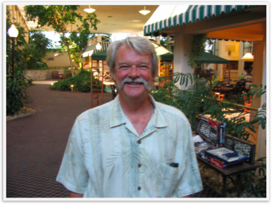

My personal thanks go to Jim Aman, our tournament director who also instrumental in persuading Grandmaster Lubomir Ftacnik to come to Columbus and play in our tournament. Lubo?s accessibility and willingness to analyze the games he played was most appreciated by his opponents and all the spectators who gathered around.  Jim advises me that Lubo enjoyed himself here, and may be persuaded to appear again next year.

My thanks also go to the many players who competed in the Columbus Open.  Some of them had been absent from chess for several years which may indicate that tournament chess is enjoying a resurgence.

Five years ago, I started guaranteeing all prize money unconditionally.  It was risky, and we lost money at first.  Beginning last year, we began to attract more players and turned a profit.  Our $1500.00 surplus last year was used to increase the prize fund by $1000.00 and to pay for an increase in the site rental.

This year we also made money, approximately $1200.00 after payment of all prize money and expenses.  I plan to put most of this money into more prizes, the amount depending on the cost of the site rental.  It is also apparent that we will need more space at next year?s playing site since comfort was somewhat lacking this year.

My aim is to keep the Columbus Open affordable yet continue to attract the kind of strong competition which has characterized this traditionally ?top-heavy? tournament.